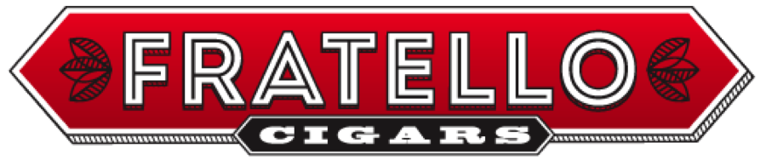

Media Contact:
Omar de Frias
202-679-1129
Email Address: omar@fratellocigar.com

CALENDAR LISTING

FRATELLO CIGAR OFFICIAL LAUNCH PARTY AT
(W. Curtis Draper)

WHAT:
Brand owner Omar de Frias is hosting a launch party at W. Curtis Draper to introduce the Fratello brand of Cigars and the Fratello Coffee Blend to cigar and coffee aficionados in Washington DC. Fratello is a leading cigar label/brand in the premium cigar market. The event is free and open to the public.

WHERE:
W. Curtis Draper
699 15th Street NW
Washington, DC 20005
WHEN:
September 20th 2013
12:00 PM – 6:00 PM

WHERE:
W. Curtis Draper
4916 Del Ray Avenue
Bethesda, MD 20814
WHEN:
September 21st 2013
12:00 PM – 6:00 PM

WHY:
Developed in Nicaragua by entrepreneur Omar de Frias, Fratello is a full-flavored cigar with a medium to full-body that is layered and complex. Notes of spices and white pepper and followed by sweet notes of syrup and nutmeg, finishing off with some nuttiness, earthy, cedar and coffee notes.
For a complete list of stores that carry the label/brand, visit www.fratellocigar.com

# # #

